**NALIN SURIYA S**

**Detect the Human and find the Occlusion factor of the Sea using Deep Learning algorithm**

**Algorithm Used:**

**YOLO ALGORITHM (YOU ONLY LOOK ONCE)**

YOLO algorithm employs convolutional neural networks (CNN) to detect objects in real-time. As the name suggests, the algorithm requires only a single forward propagation through a neural network to detect objects.

As this algorithm suited for Human Detection,Therefore I have used YOLO Algorithm

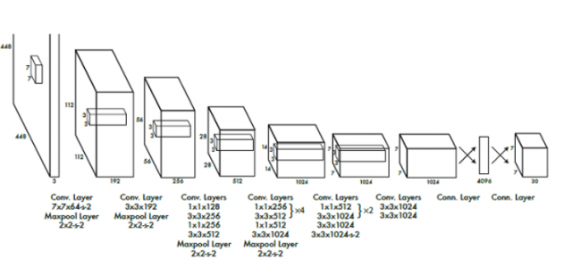

**Packages Used:**

**Open CV for Image processing**

**matplotlib for plotting charts**

**numpy for multidimensional array operations**

**WORKING OF THE MODEL:**

**Initially I loaded YOLOV3 model's weights and model configuration for the deep learning model. Then using opencv I resized the images according to the required size for the model. Then the images are fed into the model and according to model's prediction bounding boxes are generated over the input image to display it on the output. If the model's confidence is higher than 50 percent the above operation is performed.**

**CODE:**

**Github:**

https://github.com/NALINSURIYA/Human-ML

**OUTPUT:**

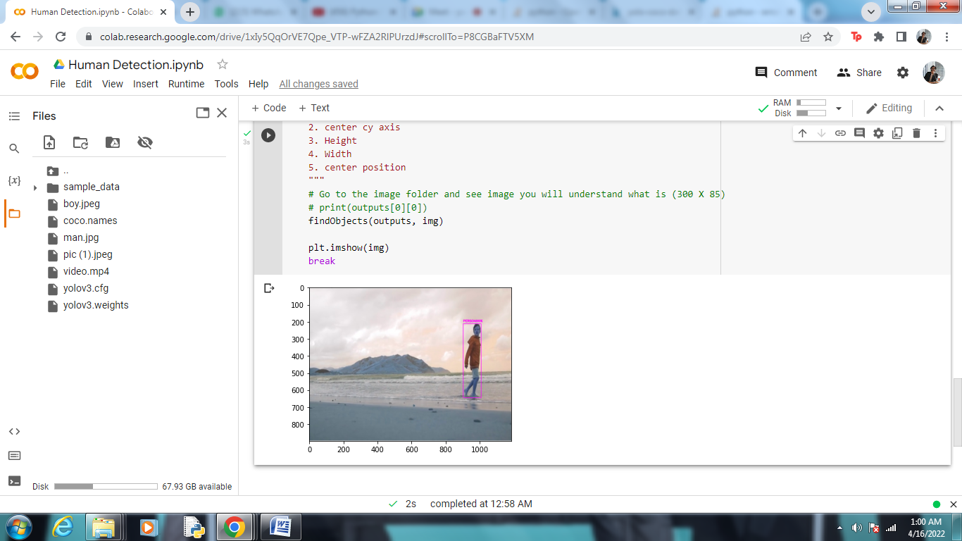

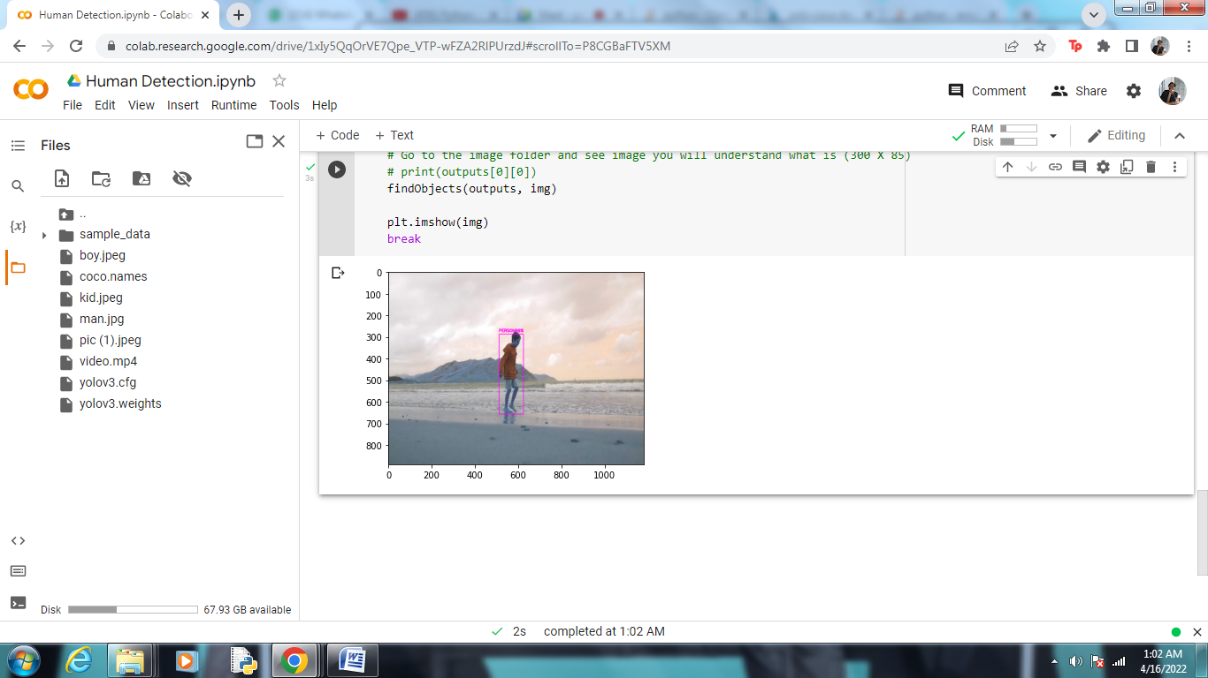

**Testing on other Data/Image:**

